Group: 17

Members: Thuy Pham, Duy Mac, Luong Nguyen

Weather Data ETL Project Report
- Project Steps, Issues, Solutions, and Insights
Step 1: Extract
- Action:
- Configured Kaggle API authentication using kaggle.json.
- Downloaded muthuj7/weather-dataset dataset automatically via Airflow.
- Unzipped the dataset, detected the correct CSV file and renamed to weather_data.csv.
- Shared dataset path to downstream tasks via XCom.
- Issues:
- Kaggle API not recognized due to missing Legacy API Credentials.
- Wrong token type (KGAT_) required switching to Legacy API Token section. Permission errors on kaggle.json.
- Solution:
- Downloaded the correct kaggle.json, placed it in ~/.kaggle/ and ~/.config/kaggle/ with chmod 600.
- Implemented CSV redundancy detection when filenames are different.
- Insight:
- Validating external APIs is often the hardest part.
- Ensuring reproducibility requires standardizing file names.
- Automated data collection ensures reproducibility and provides data updates.
Step 2: Transform
- Action:
- Converted timestamp column to datetime without time zone.
- Removed missing values ​​when using median.
- Removed duplicate rows.
- Designed new features: wind speed (m/s), wind intensity level.
- Built daily and monthly summary tables.
- Issues:
- Incompatible Python version causing syntax error (str | None type hints).
- Pandas and other packages missing from Airflow virtual environment
- Pandas gives an error: "Cannot convert Tz-aware datetime to datetime64 unless utc=True".
- Dataset instances sometimes do not contain the "Rainfall Type" column.
- Resampling fails when the DatetimeIndex is not set properly.
- Solutions:
- Updated code to use Optional[str] from typing module to support Python 3.9 in Airflow.
- Installed all necessary packages (pandas, numpy, kaggle) in correct virtual environment.
- Parsed datetime with utc=True, removed timezone with .tz_localize(None).
- Added fallback: make "Precip Type" to None when missing.
- Ensure DatetimeIndex is correct before resampling.
- Insight:
- Cleaning and transforming data is important for accurate later data analysis; missing or inconsistent values ​​can skew aggregate results.
- Time series processing is extremely sensitive to time zone formatting.
- Real-world data often has inconsistent schemas; robust ETL must be able to handle variations.
Step 3: Validate
- Action:
- Check for missing values, invalid ranges, and outliers in the daily and monthly datasets.
- Missing value checking performed for temperature, humidity and wind speed.
- Validated ranges: temperature (−50 to 50°C), humidity (0–1), wind speed ≥ 0.
- Detect temperature outliers using z-score.
- Stop the process if critical validation fails.
- Issues:
- Outlier detection shows some extreme temperature values.
- Some aggregated rows initially contained NaN due to irregular timestamps.
- Solution:
- Mark outliers in the logs but retain the data for completeness.
- Replace remaining NaN values ​​with the average value before validation.
- Insight: Validate data quality before loading, preventing bad data from affecting the analysis.
Step 4: Load
- Action:
- Loaded both tables (daily_weather, monthly_weather) into the SQLite database weather_his.db.
- Make sure the tables match the project schema.
- Issue: The database file path requires an absolute path for Airflow to write to.
- Solution: Normalize DB path in DAG.
- Insight: The loading step is only simple when the previous steps are clean and validated.
General Insights:
- Using Airflow allows for clean task sequencing and logging.
- Issues mainly arise from environment setup (Python version mismatch, package installation, API authentication).
- The project has reinforced the importance of modular code, reproducibility, and DAG debugging in Airflow.

- Group Member Contributions
Student Name | Tasks Completed
Luong Nguyen: | - Implemented the Extract step.  - Configured the Kaggle API authentication and set up the environment.  - Developed and tested the Load step.  - Verify the database correctness.
Mac Duy | - Implemented the entire Transform step.  - Fixed timezone issues and DatetimeIndex errors.  - Created the logic for aggregating and classifying wind intensity.  - Ensured the transformed CSV output is aligned with the schema.
Thuy Pham | - Implemented Validation step with detailed scope and quality checks.  - Debug Airflow DAG execution (task retries, XCom pipelines, scheduling).  - Ensured success of entire process in Airflow.  - Managed integration and final testing.  - All team members actively participated. No member was passive or uninvolved.
Notes: All three members participated actively. No member had minimal or zero contribution.

2.1️. Final Grade
- Points earned: 28/28

2.2️. Tasks Summary
- Extract function: Set up Kaggle API, download raw CSV, handle missing files.
- Transform function: Clean up, aggregate (daily and monthly), classify wind intensity, and handle type hint compatibility.
- Validate function: Check for missing values, ranges and outliers.
- Load function: Write dataset to SQLite, verify database integrity.
- Debug DAG Airflow: Ensure DAG runs correctly and tasks are executed in order.
- Images
  - Extract
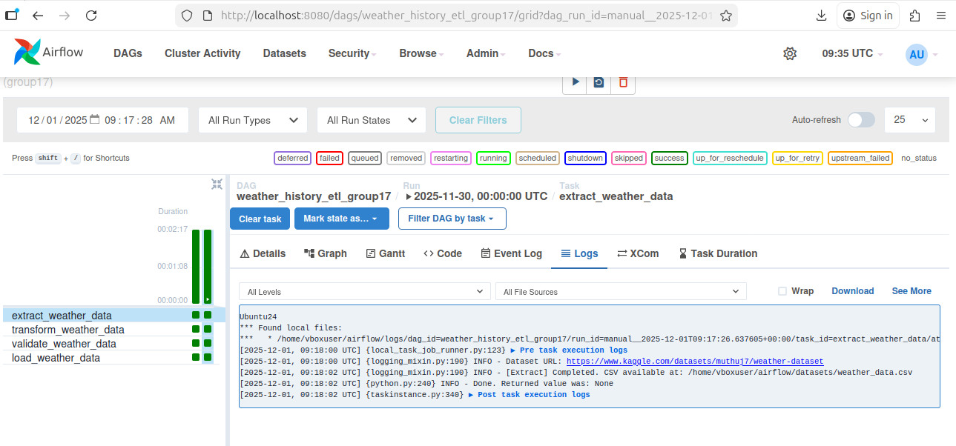

  - Transform
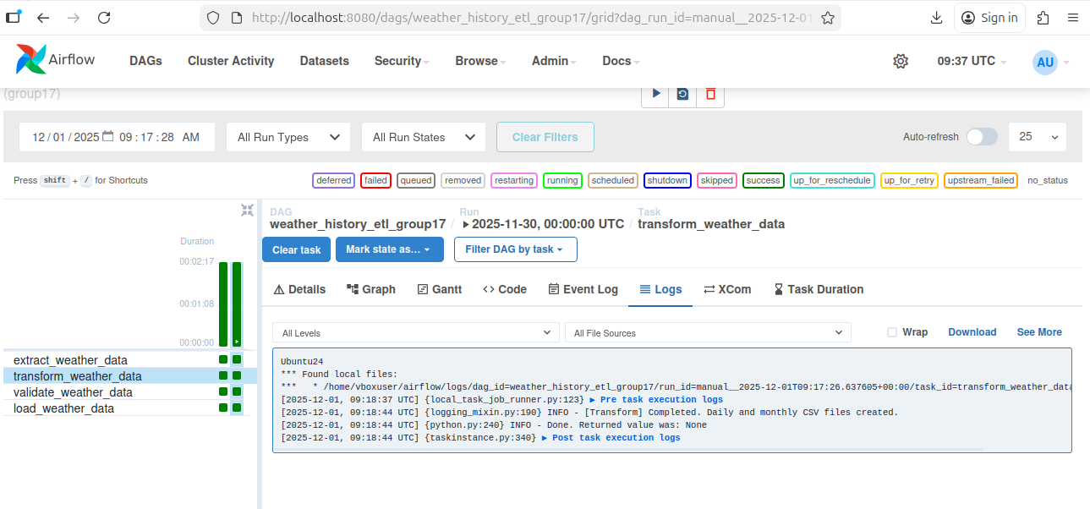

  - Validate
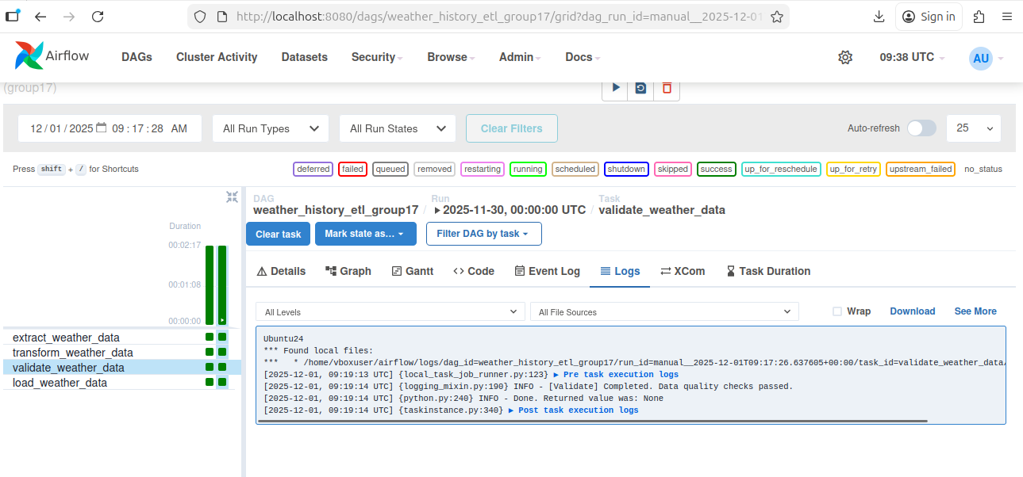

  - Load
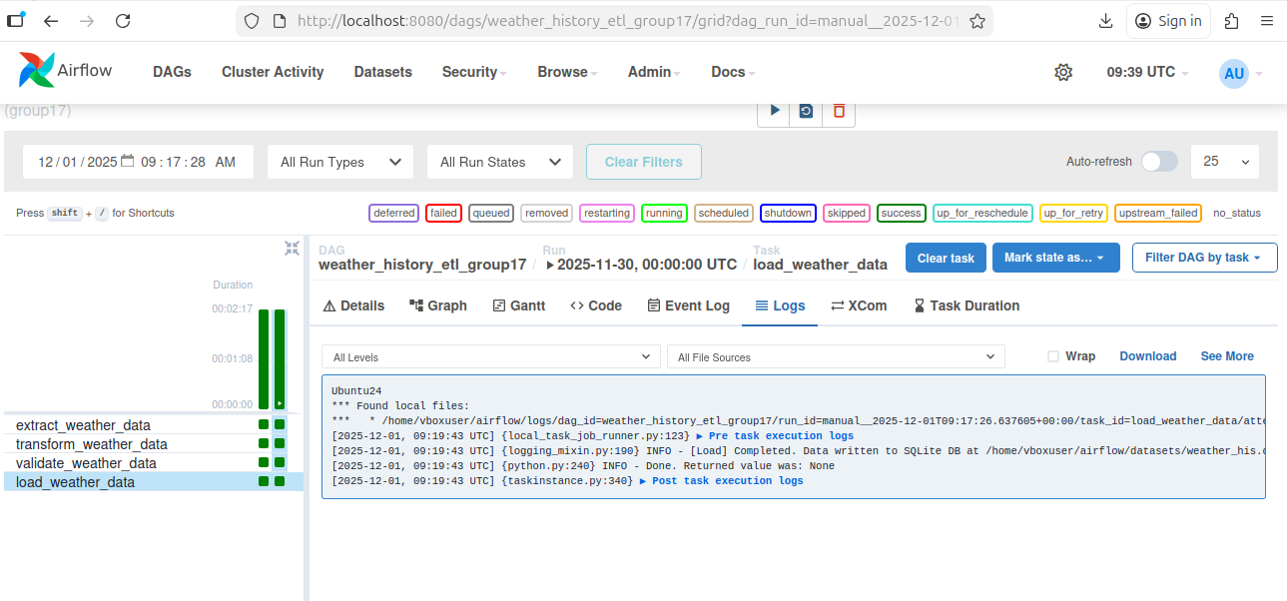

  - SQL
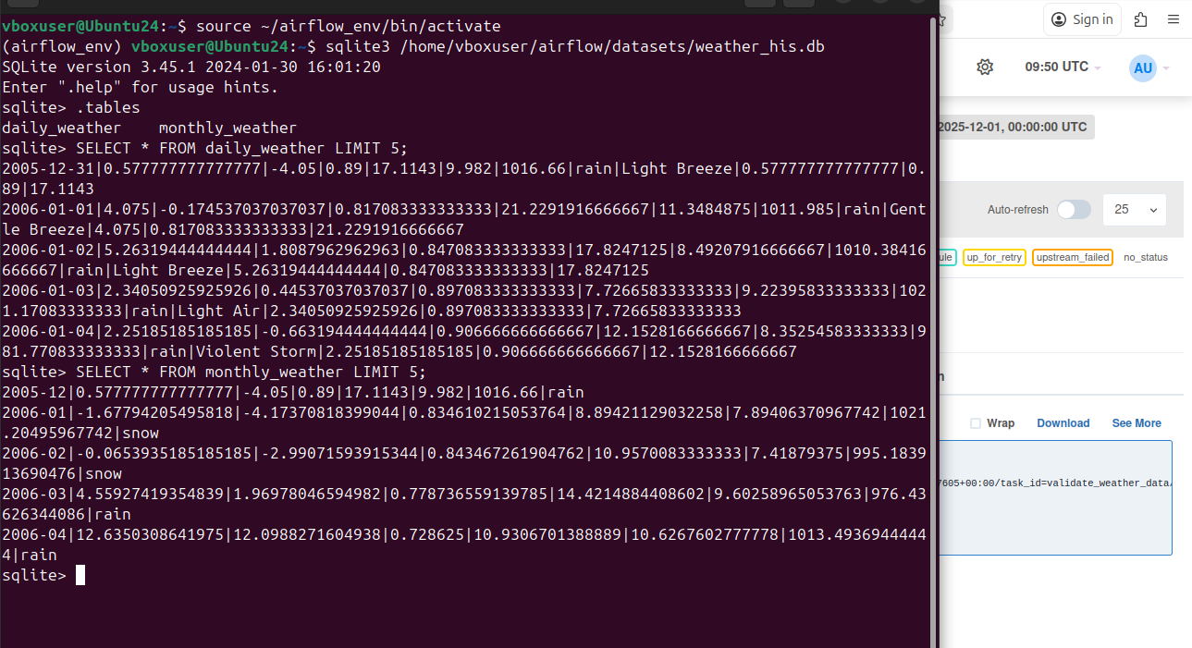

- Github:
The complete project code, including the ETL functions, screenshots, and database files, is available at:
- Github link for team work: https://github.com/LuongNguyen9a3/DE_project.git

